SETTING-UP PATIENT SERVICES ACCOUNT

When registering your Patient Services account please see these screen snips to help with this process. Once you have received the letter from NoReply@MyVisionOnline or NoReply@Patient-Services.co.uk please set up your account by clicking on the link in the letter www.patient-services.co.uk that will take you here:
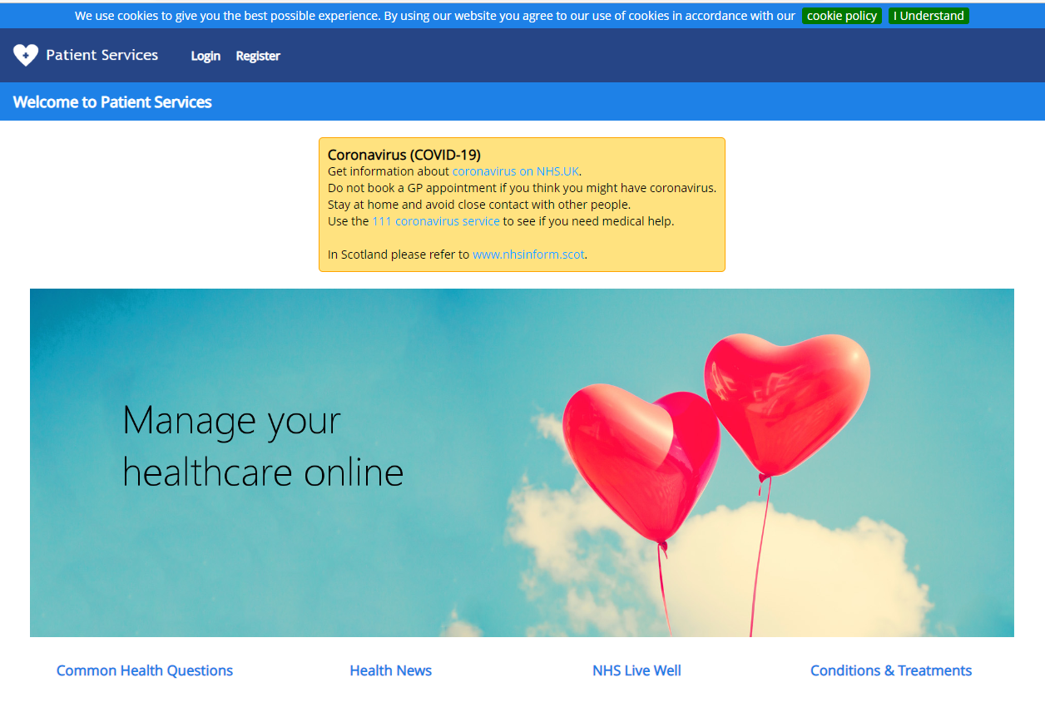

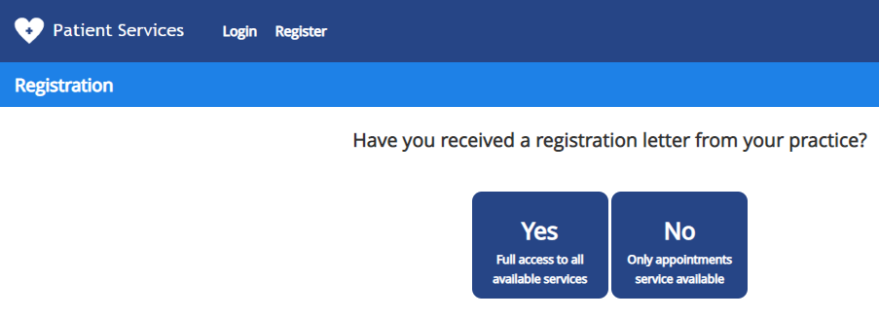
Click REGISTER
IF YOU HAVE NOT RECEIVED YOUR LETTER WITHIN 48 HOURS
PLEASE CONTACT THE SURGERY.

Click YES if you have the letter from NoReply@MyVisionOnline or NoReply@Patient-Services.co.uk

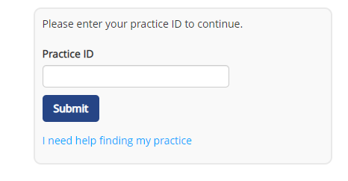
Practice ID will be in the letter

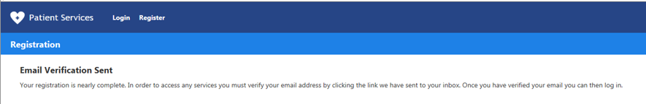
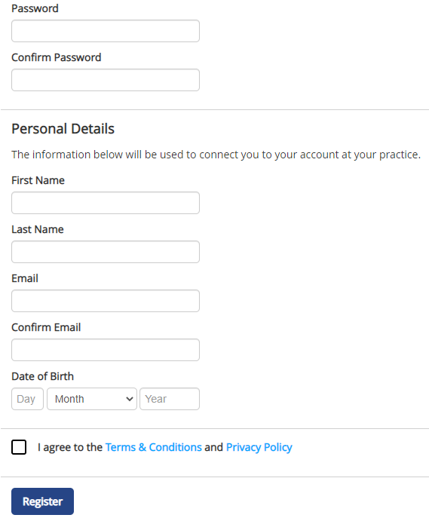
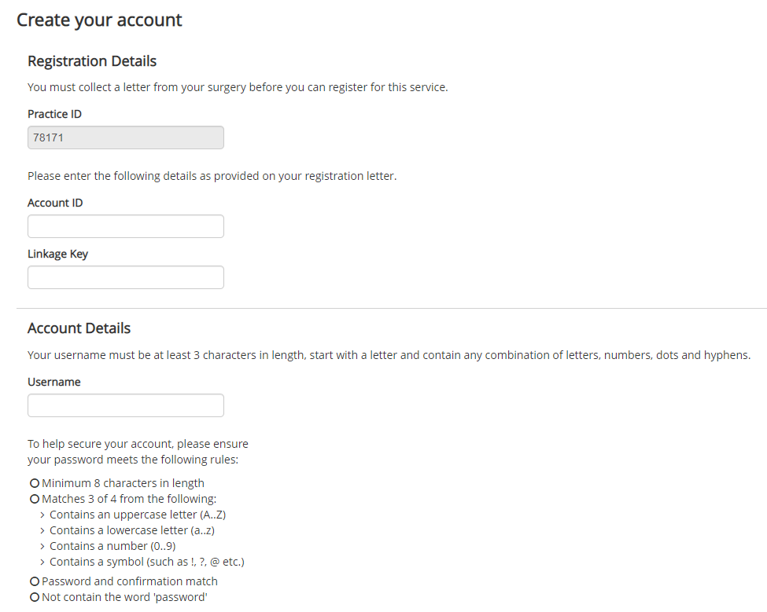
Create a memorable Password using this guide
Create a memorable Username using this guide BUT do not use @ symbol in username.

You must verify your email address by clicking the link sent to your inbox. Once you have verified your email address you can then log in.
Account ID and Linkage Key will be in letter emailed to you from MyVisionOnline. Ensure Linkage Key is exactly as in the letter.
Check box to agree to Terms & Conditions
When you click ‘Register’ you will then be sent a verification email, which you must respond to before you try to log-in to your account.
If you do not receive this verification email within 24 hours please contact the surgery.
When you have verified your email address please log-in to Patient Services to request your prescription(s).
Once you have verified your email, please log-in to your account:
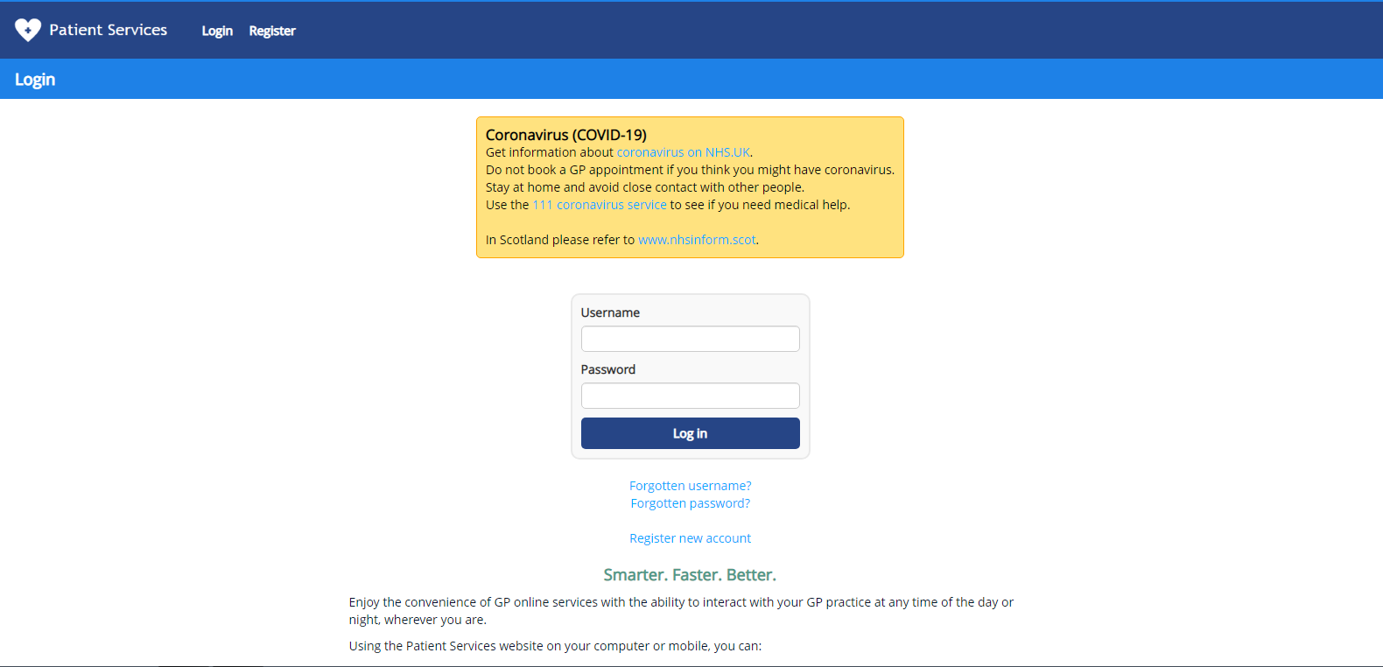

On successful log-in you should see the screen below: (The Welcome message may change.)
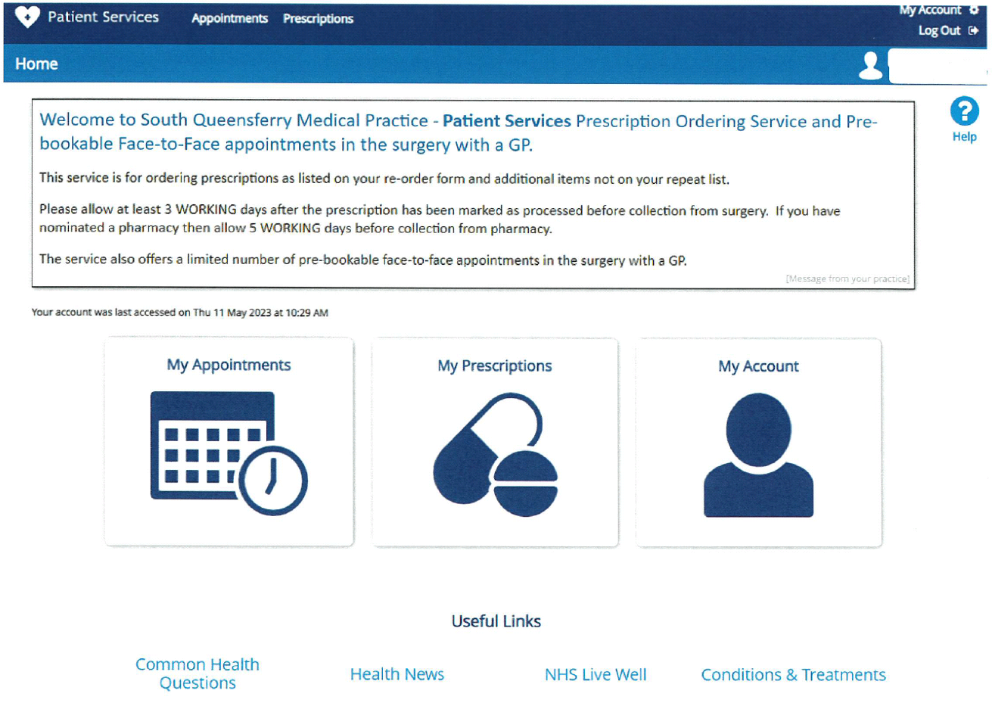
When ‘My Prescriptions’ selected you should see a list of repeat medications if you have any and a section below to request expired repeats or other medications not on repeat.

Please remember to select the ‘Request’ button. You will receive a confirmation email when we receive your prescription request.
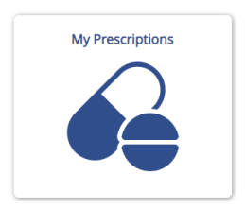

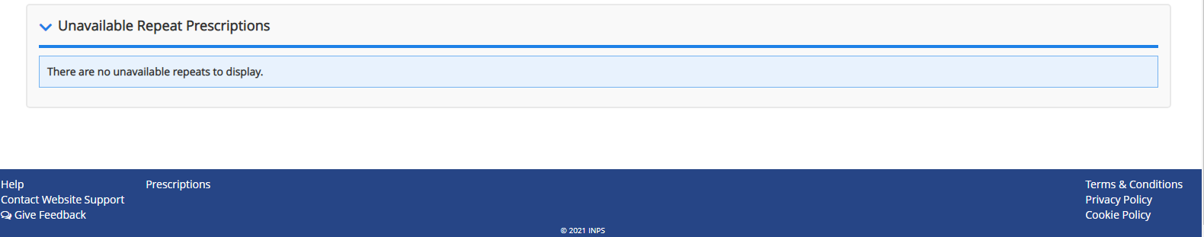
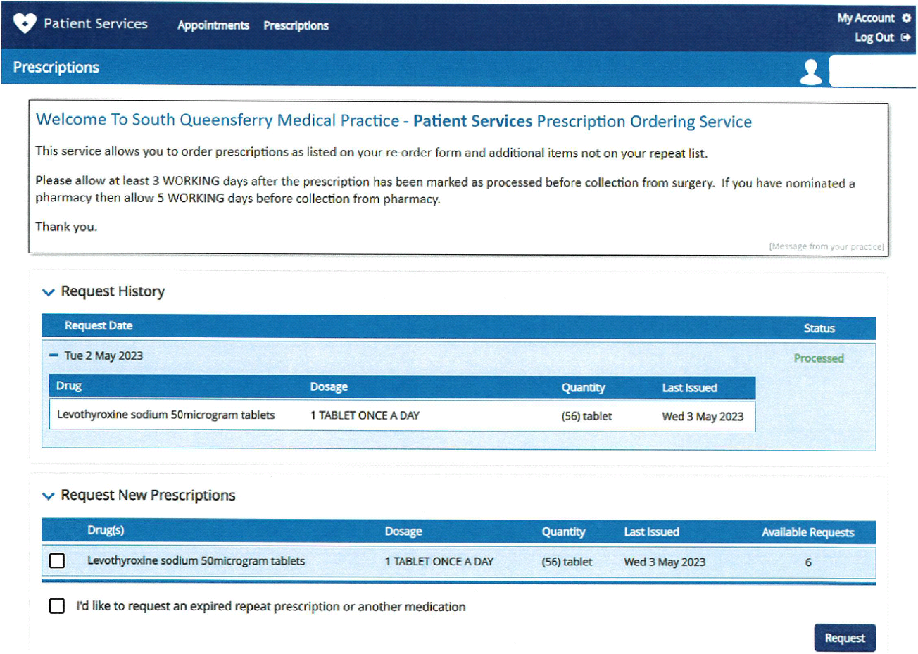
Please allow at least 3 working days after submission of request to collect prescription from the surgery.

If you have a preferred pharmacy on your record please allow at least 5 working days from submission before collecting medication.
When ‘My Appointments’ clicked, select ‘+ Add New Appointment’ and you will see the Appointment Search Filter – you can then add to the filter to search times, dates and specific GPs. When results displayed, select the appointment suitable for you and click ‘book’. Please note all the appointments available to book are with a GP for a face-to-face consultation in the surgery.

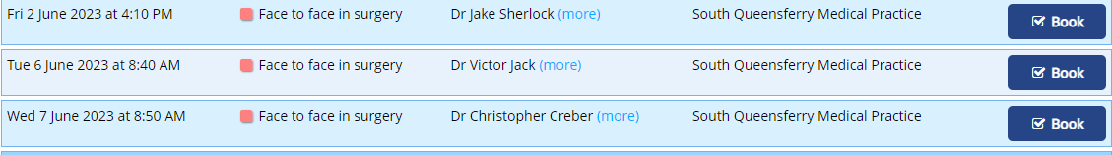
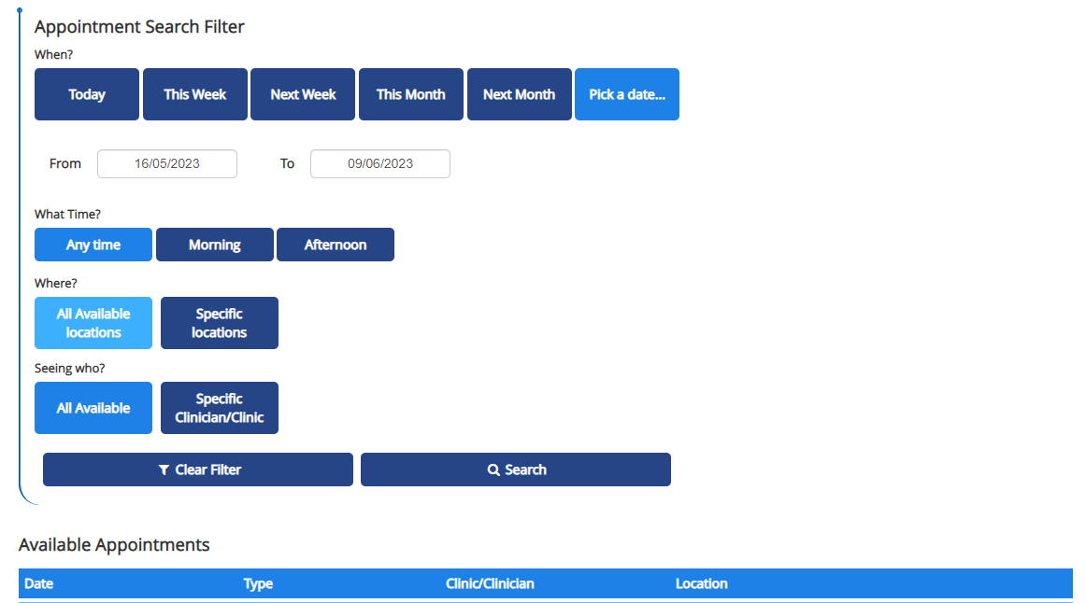
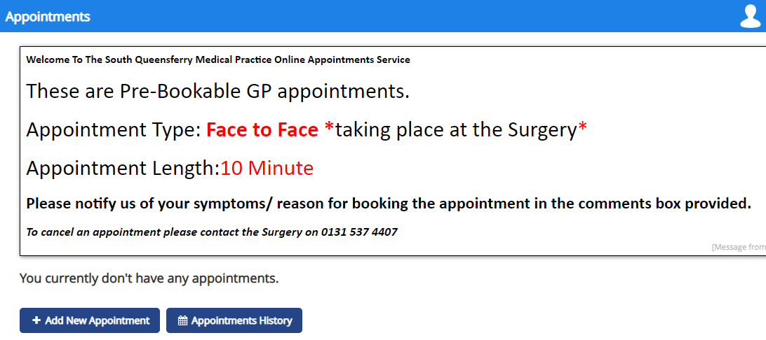
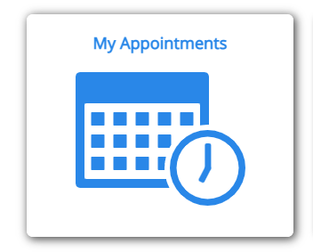

When appointment selected and booked the following is displayed:

Please add details to ‘Reason for appointment’ as this is helpful to the GP.
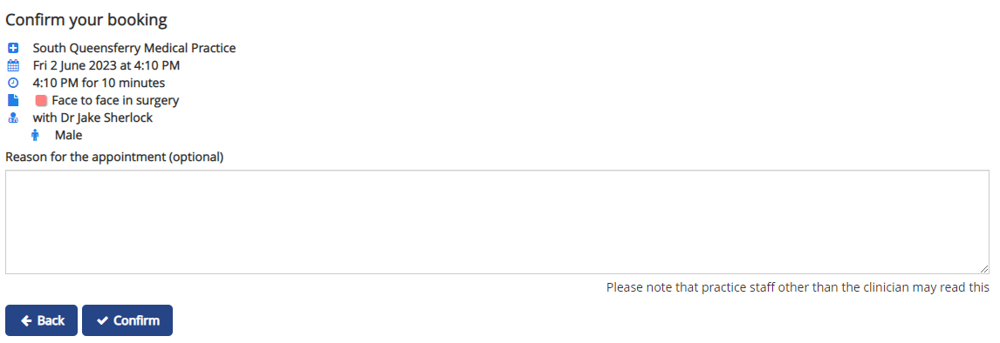

Please remember to click ‘Confirm’ to secure your booking.
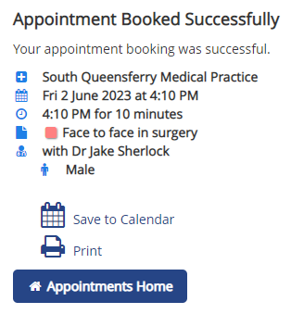

To cancel booked appointments, go to ‘Appointments Home’ and select ‘Cancel’ for the appointment(s) you wish to cancel.
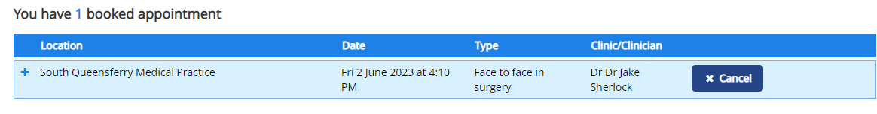

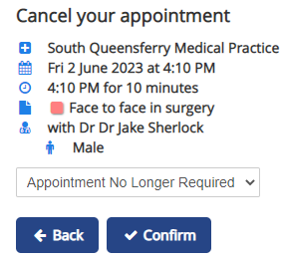

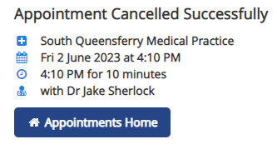

Please remember to click ‘Confirm’ to cancel your booking.

