SETTING-UP PATIENT SERVICES ACCOUNT

When registering your Patient Services account please see these screen snips to help with this process. Once you have received the letter from MyVisionOnline please set up your account by clicking on the link in the letter www.patient-services.co.uk which will take you here:
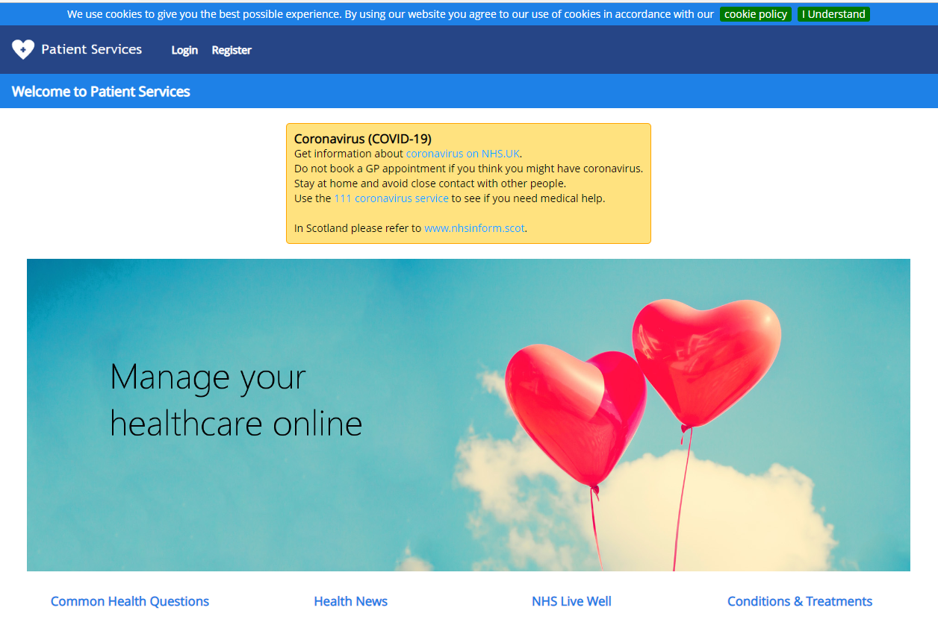

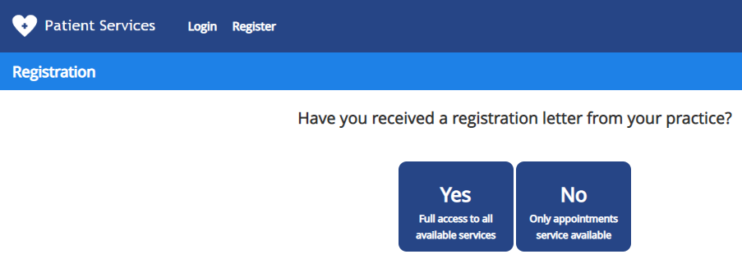
Click REGISTER
IF YOU HAVE NOT RECEIVED YOUR LETTER WITHIN 48 HOURS
PLEASE CONTACT THE SURGERY.
Click YES if you have the letter from MyVisionOnline

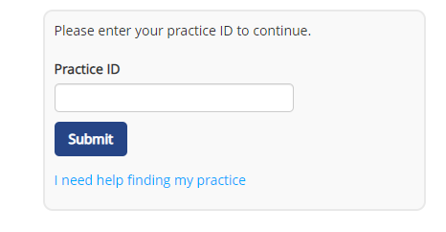
Practice ID will be in the letter

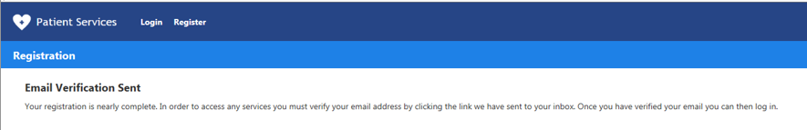
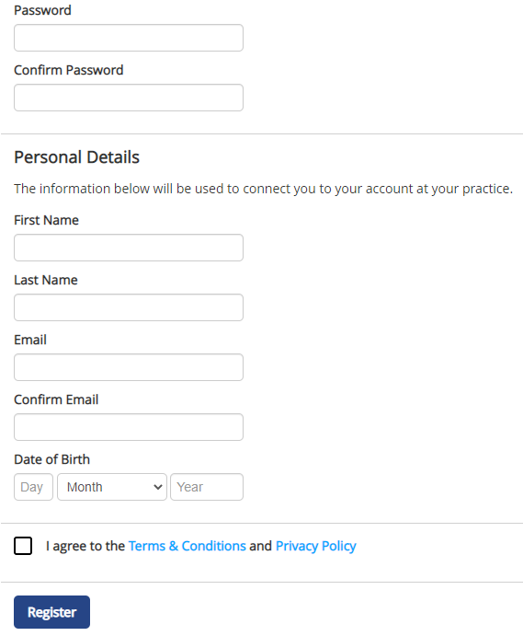
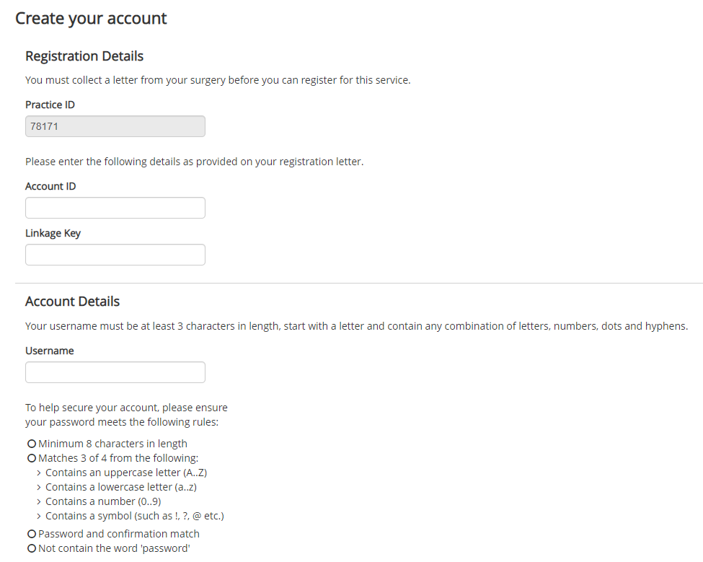
You must verify your email address by clicking the link sent to your inbox. Once you have verified your email address you can then log in.
Create a memorable Password using this guide
Create a memorable Username using this guide
Account ID and Linkage Key will be in letter emailed to you from MyVisionOnline. Linkage Key must be put in exactly as in the letter.
Check box to agree to Terms & Conditions
When you click ‘Register’ you will then be sent a verification email which you must respond to before you try and log-in to your account.
If you do not receive this verification email within 24 hours please contact the surgery.
When you have verified your email address please log-in to Patient Services to request your prescription(s).
Once you have verified your email please log-in to your account:
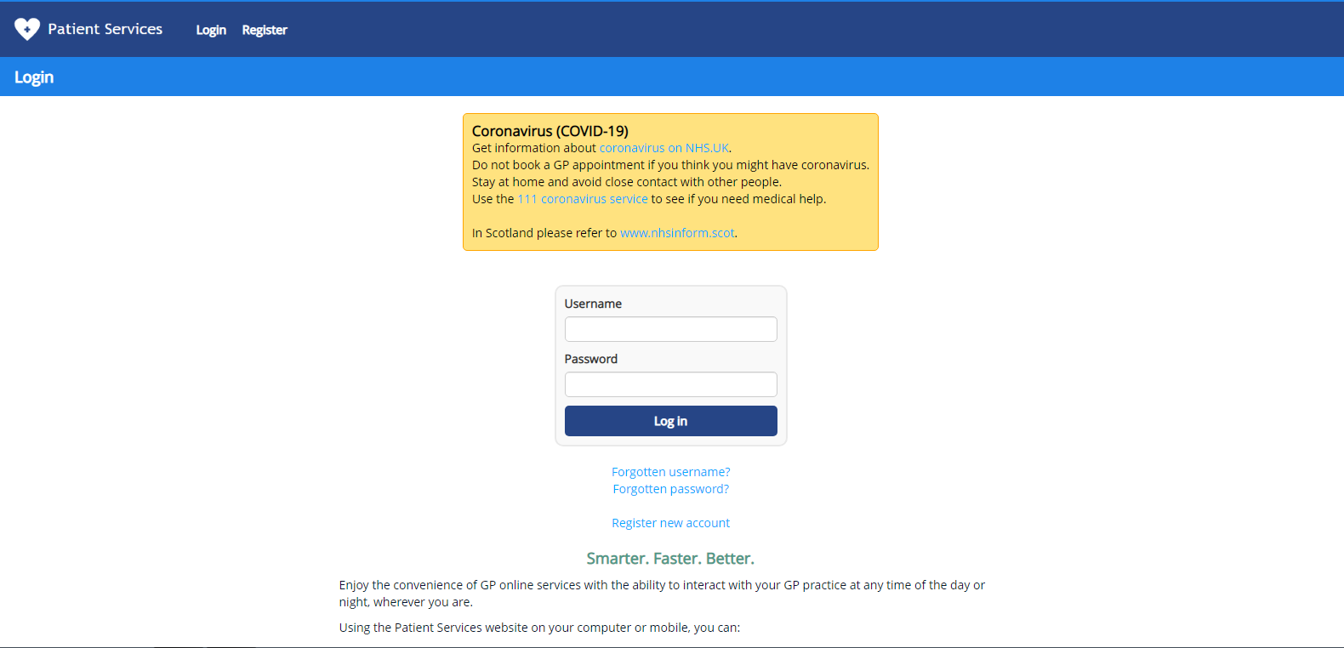

On successful log-in you should see the screen below: (The Welcome message will be different.)
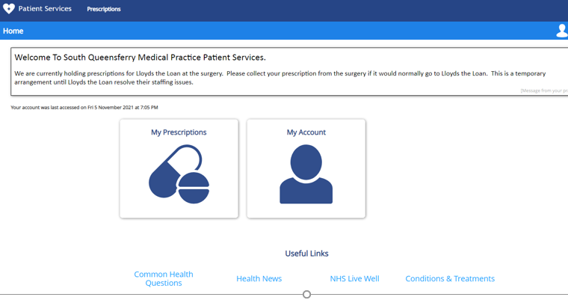
When ‘My Prescriptions’ selected you should see a list of repeat medications if you have any and a section below to request expired repeats or other medications not on repeat.

Please remember to select the ‘Request’ button. You will receive a confirmation email when we receive your prescription request.
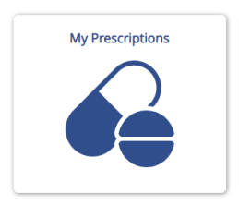

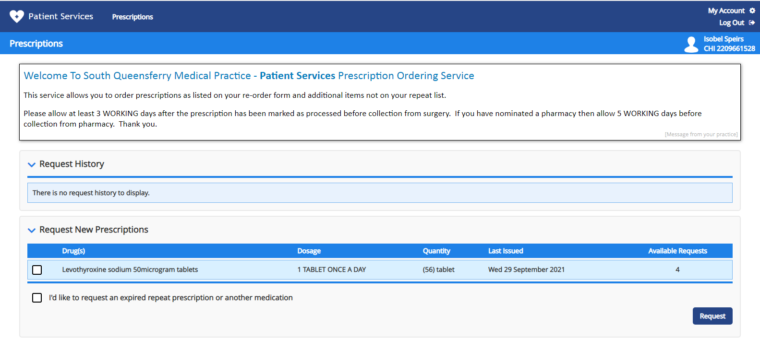
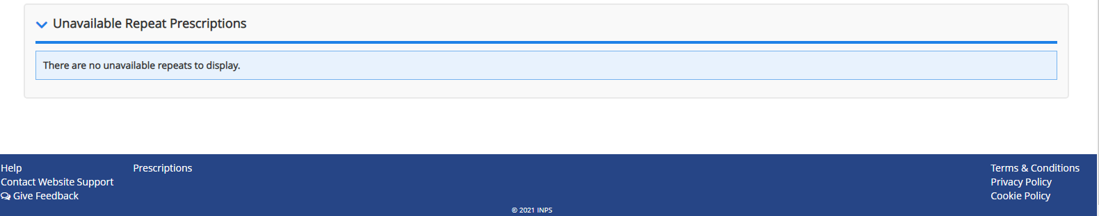

Please allow at least 3 working days after submission of request to collect prescription from the surgery.

If you have a preferred pharmacy on your record please allow at least 5 working days from submission before collecting medication.

